# Experiment No.: 14 Date: 07-03-2023

**AIM**: Familiarization of linux commands.

**CO4**: Write shell scripts to perform system administration tasks.

**Procedure:**

1. switch case statement program

#!/bin/bash

fruit="mango"

case "$fruit" in

"banana") echo "the fruit is banana";;

"orange") echo "the fruit is orange";;

"mango") echo "the fruit is mango";;

esac

**output**

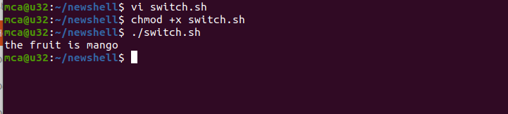

# Result

The program was executed and the result was successfully obtained. Thus CO4 was obtained

**Procedure:**

1. switch case statement program to display capitals

#!/bin/bash

read -p "Enter the state :" state

case "$state" in

"tamilnadu") echo "chennai is the capital of tamilnadu";;

"kerala") echo "Trivandrum is the capital of kerala";;

"goa") echo "pananji is the capital of goa";;

esac

**output**

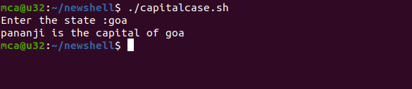

# Result

The program was executed and the result was successfully obtained. Thus CO4 was obtained

**Procedure:**

1. switch case statement program to enter a letter of vibgyor and tell what color it is

#!/bin/bash

read -p "Enter any letter of VIBGYOR: " color

case "$color" in

"v") echo "color is violet";;

"i") echo "color is indigo";;

"b") echo "color is blue";;

"g") echo " color is green";;

"y") echo "color is yellow";;

"o") echo "color is orange";;

"r") echo "color is red";;

*) echo "Enter a valid color";;

esac

**output**

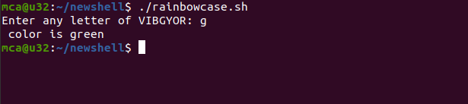

# Result

The program was executed and the result was successfully obtained. Thus CO4 was obtained

**Procedure:**

1. while loop to print 10 numbers

#!/bin/bash

a=0;

while [ $a -lt 10 ] less than or equal to le,ge

do

echo $a

a=`expr $a + 1` or you can give ((a++))

done

**output**

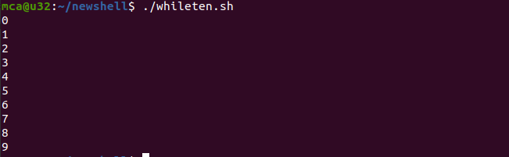

# Result

The program was executed and the result was successfully obtained. Thus CO4 was obtained.

**Procedure:**

1. while loop to print 10 numbers in reverse order

#!/bin/bash

a=10;

while [ $a -gt 0 ]

do

echo $a

a=`expr $a - 1`

done

**output**

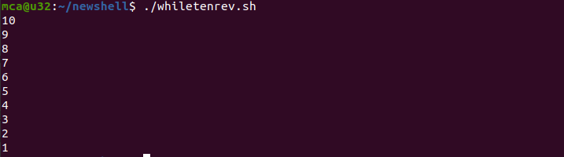

# Result

The program was executed and the result was successfully obtained. Thus CO4 was obtained

**Procedure:**

1. Palindrome or not

#!/bin/bash

read -p "Enter a number " num

temp=$num

while [ $temp -gt 0 ]

do

((rem=temp%10))

((rev=rev*10 +rem))

((temp=temp/10))

done

if [ $rev == $num ]

then

echo "number is palindrome"

else

echo "not a palindrome"

fi

**output**

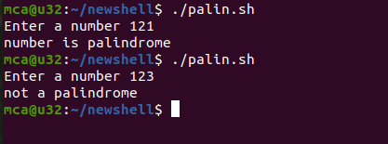

# Result

The program was executed and the result was successfully obtained. Thus CO4 was obtained.e